Topic 6 Review Notes:

6.1 – 6.2 Terminating, Repeating, and Non-Repeating Decimals
Terminating  - A decimal that ENDS (Think about how an “exterminator” ENDS the bugs)  - Example: 0.2346 | Repeating  - Repeats the same block of numbers forever  - Example: 0.45454545… | Non-Repeating  - Never repeats and goes on forever  - 0.15262847492…
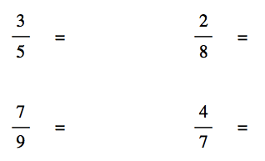
Long Division
- “Top dog in the house”
- Top number of the fraction goes under the long division house.
- Bottom number in fraction goes on the outside of the house.
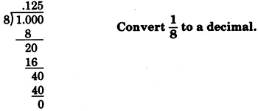
- Example:
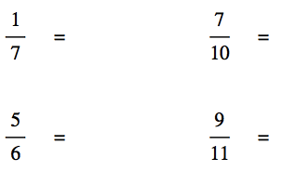

6.3 – 6.4 Percents Greater than 100 and Less than 1
Greater than 100  - 150%  - This is usually a comparison of the old and the new. For example, the old item might be 100% where the new item might have increased to 300%, or 3 times as much.  - Example: On Monday, Miss Mampre drove 20 miles. Over the weekend, she took a road trip and drove 80 miles. She drove _____% miles over the weeknd than Monday.  - 20 80 = x4  - So 100 x 4 = 400% | Less than 1  - A fraction of a percent (NOT EVEN A WHOLE PERCENT!)  - This is usually all about conversions, really understanding what a fraction of a percent is.  - Example: What percent is 12 of 3000?  Is over of = percent over 100  - 12/3000 = x/100 so x = 0.4%  - Write 0.78% as a fraction and a decimal.  - 78/100% 0.78% / 100 = 0.0078

6.3 – 6.4 Percents Greater than 100 and Less than 1 PRACTICE

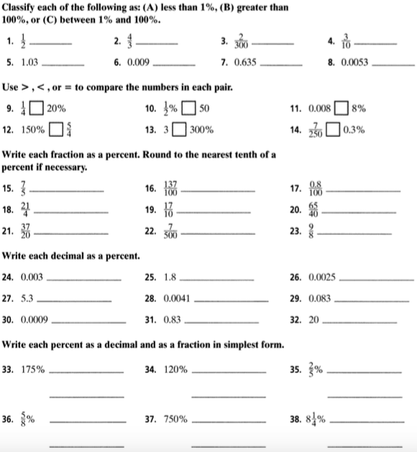

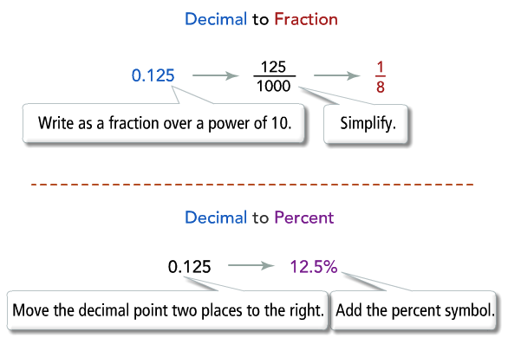
6.5 Converting between fraction, decimals, percents:

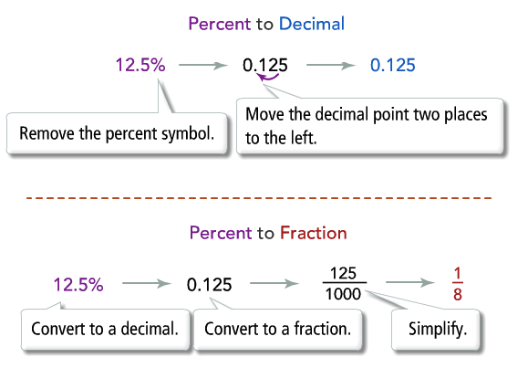
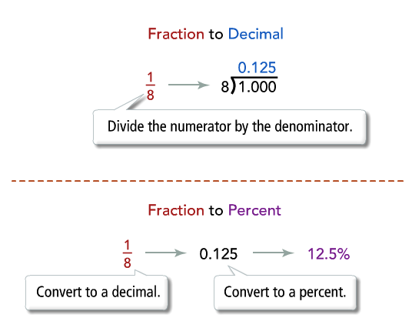

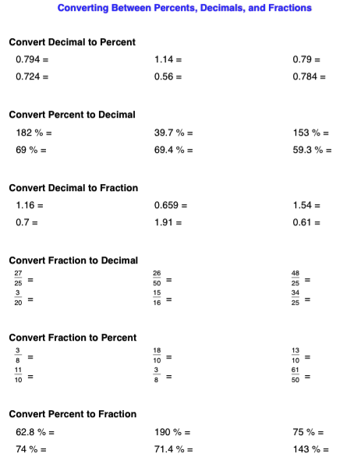

6.6 Percent Error

Finding the percentage of how far off your estimate is off of from the actual.
The closer to zero the better your estimate is.
There never is 100% error.

FORMULA:

Percent Error = |Actual – Estimated| x100
Actual

BE SURE YOU TAKE THE ABSOLUTE VAULE!

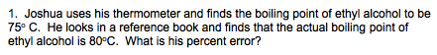

Actualy: 80
Estimate: 75 (Even though he “actually” read it from the thermometer, it was still a tool to estimate. The scientific answer is the actual value.)

Percent error = | 75 – 80 | x 100 | -5 | x 100 5 x 100 = 6.7% error
75 75 75

