Name: ___________________________________________________________ Period: _________

Prentice Hall Chapter 1 Review

**Topics:**

* Algebraic Expressions
* Exponents
* Order of operations
* Adding/Subtracting rational numbers
* Multiplying/dividing rational numbers
* Distributive Property
* Properties of real numbers
* Coordinate plane

**Algebraic Expressions / Exponents / Order of Operations:**

***Write an algebraic expression for each phrase.***

1. The sum of 5 and three times a number

1. 30 minus a number
2. The quotient of 7 and a number
3. The product of a number and 12

***Evaluate each algebraic expression for a = 3, b = 2, c = 1***

1. 2a2 – (4b + c) 6. 9(a + 2b) + c 7. 4a – b2

***Evaluate each exponent.***

1. 43 9. 82 10. -32

**Adding / Subtracting Rational Numbers:**

***Simplify each expression.***

1. -13 + (-4)
2. -12 – (-7)
3. 5 – 17
4. -3 + 9
5. 4 + (-4)
6. -32 + (-32)

**Multiplying / Dividing Rational Numbers:**

***Simplify each expression.***

1. (3)(2)
2. 5(4)(-2)
3. 
4. 
5. 4 • (-4)
6. 

**Distributive Property:**

***Simplify each expression.***

1. 9m – 5m +3
2. 9(4 – 3j)
3. (6 – 3m)(3)
4. – (3 – 10y)
5. 7 – 16v – 9v
6. – (4 – x)

**Properties of Real Numbers:**

***Name the property that each equation illustrates.***

1. 62 + 15 + 38 = 62 + (15 + 38)
2. 50 • 17 • 2 = 50 • 2 • 17
3. 37 + 0 + (9 + 16) = 37 + (9 + 16)

***Pick two properties and give your own example.***



**Graphing on a coordinate plane:**

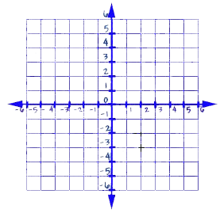***Label each quadrant. Identify the following as positive, negative,***

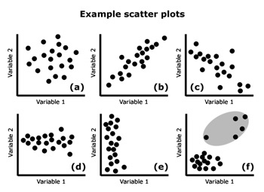***or no correlation.***

***Identify the ordered pair for each point on the grid.***

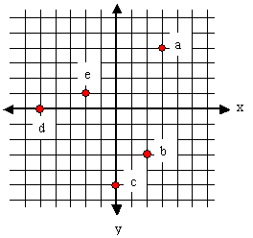

***a: ____________***

***b: ____________***

***c: ____________***

***d: ____________***

***e: ____________***

***Plot and LABEL the following ordered pairs on the coordinate grid below.***



***J ( 0, -6)***

***K (-3, 4)***

***M (5, 1)***