Name: ___________________________________________________________
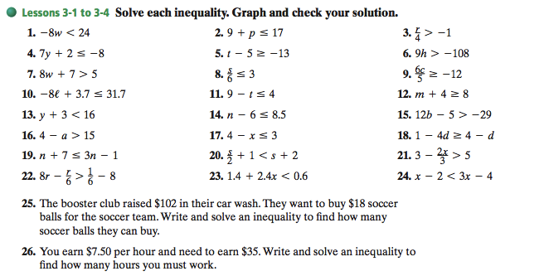
Review 3.1-3.4

Name: ___________________________________________________________
Review 3.1-3.4

