Name: ______________________________________________________________________________ Period: ________

Solving Equations Review

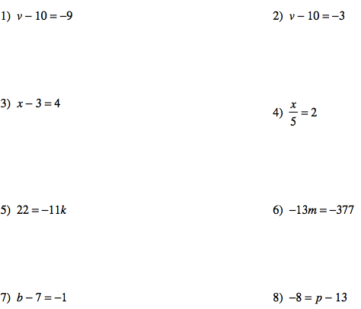

PART ONE:
SOLVING
ONE STEP
EQUATIONS

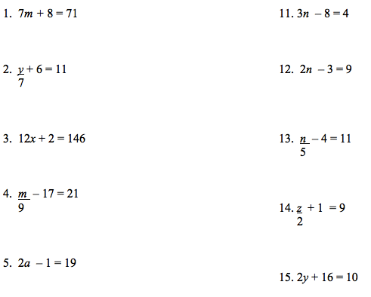

PART TWO:
SOLVING
TWO STEP
EQUATIONS

PART THREE:
COMBINGING LIKE TERMS AND
SOLVING EQUATIONS

