Name: ____________________________________________________________________________ Period: ________

3.4 Exponents and Division

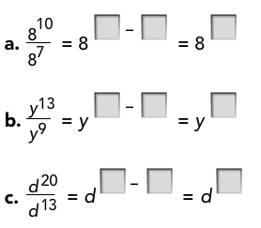



To divide powers with the same base,

subtract the exponents.

