Name: ______________________________________________________________________________ Period: __________

7.4 Subtracting Algebraic Expressions

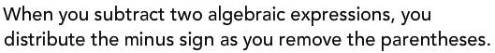

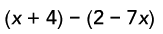
DRAW DISTRIBUTING ARROWS
**REMEMBER: A _______________________________ sign in front of
the parenthesis really means to distribute a ___________ to
each term inside of the parenthesis.

