Name: ______________________________________________________________________________ Period: __________

Terms | Coefficient | Constant
7.3 Adding Algebraic Expressions

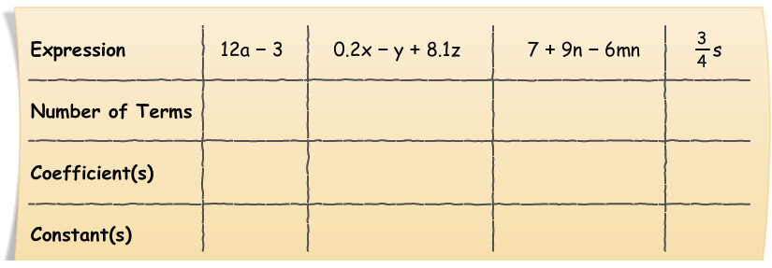

Combining Like Terms:
- ___________________________ any constants outside of the parenthesis to each term inside of the parentheses (Include the sign!!)
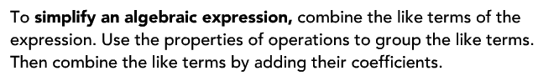
**REMEMBER: A _______________________________ sign in front of the parenthesis really means to distribute a ___________ to each term inside of the parenthesis.

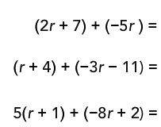
**Try using the underline technique.
-Single line “like variables”
-Double line other “like variables”
-Circle all “constants”

