Name: ______________________________________________________________________________ Period: __________

7.2 Factoring Algebraic Expressions

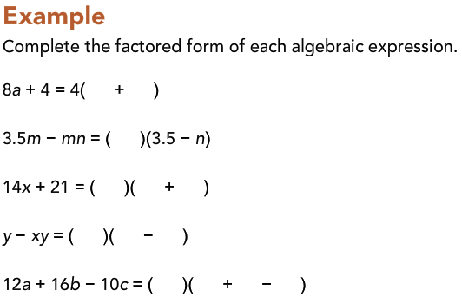

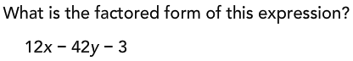

Combining Like Terms:
- You can only combine values that are similar.
- You can only combine _______________________________with other _______________________________.
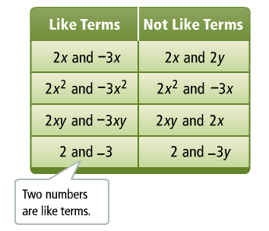
- You can only combine _______________________________with other _______________________________.
Examples: 9x + 7x

y + 2.5y – 3y

