Name: ______________________________________________________________________________ Period: __________

6.1 What is a System of Linear Equations in Two Variables?
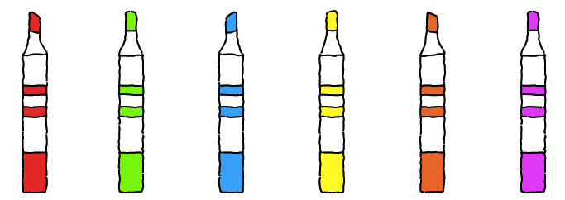
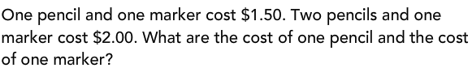

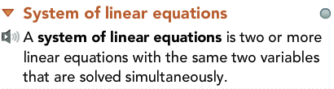 | EXAMPLE:
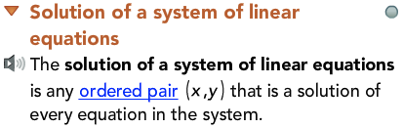 | EXAMPLE:
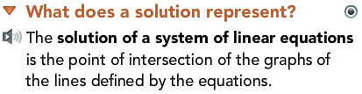 | EXAMPLE:

System of Equations | 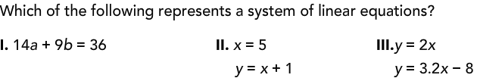  Not a System

