Name: ________________________________________________________________________________ Period: __________

Vocabulary

Domain:
- Set of first coordinates in an ordered pair. (the x values)
Range:
- Set of second coordinates in a ordered pair (the y values)
Relation:
- Set of all ordered pairs; x value may be repeated
Function f(x) or y:
- a relation that assigns exactly one value in the range to each value in the domain.
(x value may not be repeated)

Giraffes
Age (years) | Height (meters)
18 | 4.25
20 | 4.40
21 | 5.25
14 | 5.00
18 | 4.85
Relation:

Function:

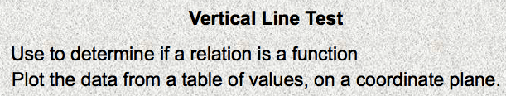

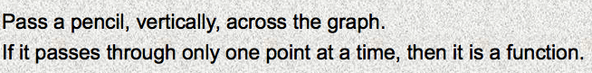

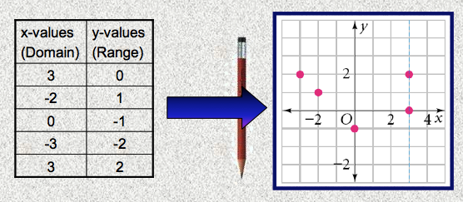

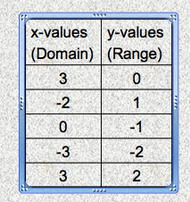

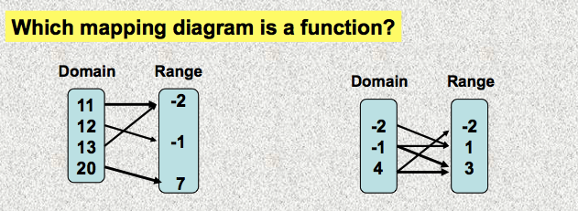

Domain  (x value) |  | Range  (y value)
Function rule
f(x) = 2x + 4
y = 2x + 4

