Name: _______________________________________________________________________________ Period: ____________

Graphs are used to show relationships between two variables. Data shown can be interpreted as:

1.) increasing slowly or quickly 2.) decreasing slowly or quickly

3.) remaining constant

When interpreting graphs:

- ________________________________________________________________________________________________________

- ________________________________________________________________________________________________________
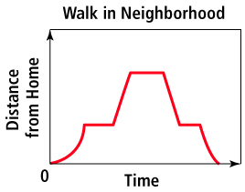

Why does this graph show a car sitting at a stoplight?

A pelican flies above the water searching for fish. Sketch a graph of its altitude from takeoff from shore to diving to the water to catch a fish. Label each section.

